Problem statement
A company deploys a software for time-keeping system. At the reception desk, a computer runs this software to get check-in and check-out times by employees as following:
- When each employee arrives at company for the first time in working day, he/she needs to use the computer to select the Check-in feature on this software. He/she only input the Employee ID, then click OK to confirm the ID, the software will automatically get system time and store as check-in time.
- Similar to the check-in feature, when each employee leaves company for the last time in working day, he/she needs to select the Check-out feature on this software and input the Employee ID, the software will get system time and store as check-out time.
This software also supports the management board in some operations as followings:
- Manage employee information (add, modify, delete employees).
- Adjust the check-in and/or check-out time for employees when necessary.
- Calculate all employees’ salary at regular times, for example: the 25th every month. When the accountant selects the Salary Calculation feature, the software will do this. Then the salary needs to be approved by manager so that it can be paid to employee later.
Rule for calculating salary is simple as below:
o Each working day starts from 8:00, ends at 17:00.
o If the late check-in is before 10:00, the salary of that working will be deducted 20,000 VND.
o If the late check-in is since 10:00, the salary of that working will be deducted half-day’s salary.
o If the early check-out is after 15:00, the salary of that working will be deducted 20,000 VND.
o If the early check-out is before 15:00, the salary of that working will be deducted half-day’s salary.
The system is planned to be developed using a client-server architecture:
- The client will be implemented with React technology.
- The server will be a REST API following the MVC pattern (e.g., ASP.NET Core Web API, Spring Boot Rest API, Rest API with node.js…).
- The database will be Microsoft SQL Server (MS SQL), MySQL or PostgreSQL.
- Communication between client and server is done via HTTP requests/responses using JSON data format.
Part 1: Data analysis and design (5 points)
1. List the main entities and their key attributes based on the problem description. (1 point)

Employee : EmployeeID , FullName , Position , Department , Status , Role
Attendance : Attendance , EmployeeID , Date , CheckInTime , CheckOutTime
Salary : SalaryID , EmployeeID , Month , BaseSalary , TotalWorkingDays , FinalSalary , Deduction

2. Apply UML’s Class diagram to draw the conceptual ERD for the system. (1 point)

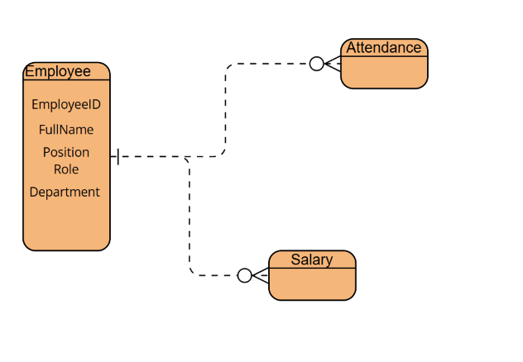

3. Apply UML’s Class diagram to draw the logical ERD (with primary/foreign keys and basic data types) for the system. (1.5 points)
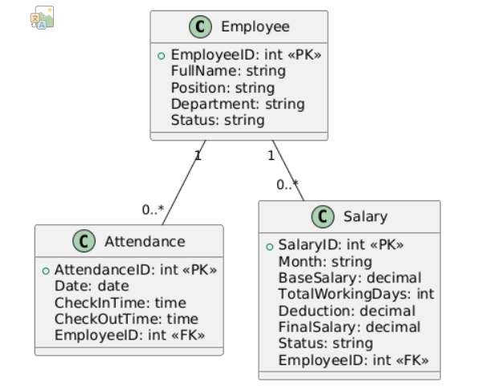
4. List the main states of the Salary entity during calculation/paying process, and draw the state diagram for it. (1.5 points)

Uncalculated : Chua tinh luong
Calculated : da tinh luong => luu luong vao database
WaitingApproval : cho duyet boi manager
approved : duoc duyet , dang cho thanh toan
Paid : da thanh toan
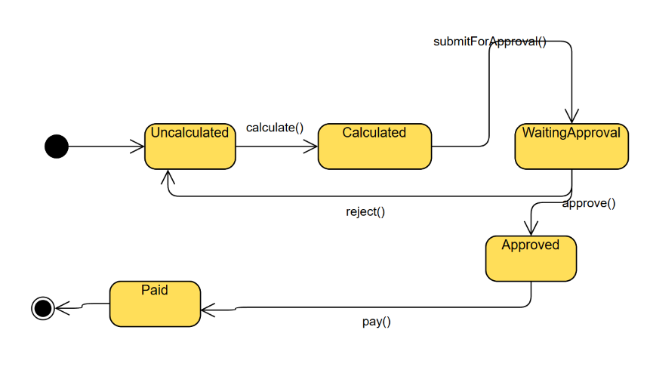

Part 2: REST API function design (3 points)
1. Describe the classes/tables used on the client side, server side (MVC: Controller, Service, Repository), and in the database for the "Salary Calculation" function. (1 points)

Layer | Component Type | Class / Table Name | Role / Description
Client (React) | UI Component | SalaryCalculationPage.jsx | Renders UI for accountant to trigger salary calculation.
 | API Helper Module | salaryApi.js | Sends HTTP POST request to /api/salary/calculate with attached JWT token.
 | Auth Context | AuthContext.js / useAuth() | Stores authentication token and user role.
 | HTTP Communication | axios.post(...) | Standard format for sending JSON data and authorization headers via HTTP.
Server (MVC) | Controller | SalaryController | Receives API requests, delegates to SalaryService, and returns response.
 | Service | SalaryService | Contains business logic to compute salaries using attendance data and deduction rules.
 | Repository | AttendanceRepository | Queries check-in/check-out data from Attendance table.
 |  | SalaryRepository | Saves calculated salary data into the Salary table.
 |  | EmployeeRepository | Fetches employee information for salary calculation.
 | Middleware | (e.g., JWTMiddleware) | Validates JWT token and checks if user has correct role (e.g., Accountant).
Database | Table | Employee | Stores employee information: EmployeeID, FullName, BaseSalary, etc.
 | Table | Attendance | Stores daily check-in/out: CheckInTime, CheckOutTime, Date, etc.
 | Table | Salary | Stores salary results per month: Month, Deduction, FinalSalary, Status, etc.

2. Draw a sequence diagram for the "Salary Calculation" function between client and server (REST API) with authentication and authorization. (2 points)
Accountant
Client (React app)
AuthService :
SalaryController
SalaryService
SalaryRepository
Database
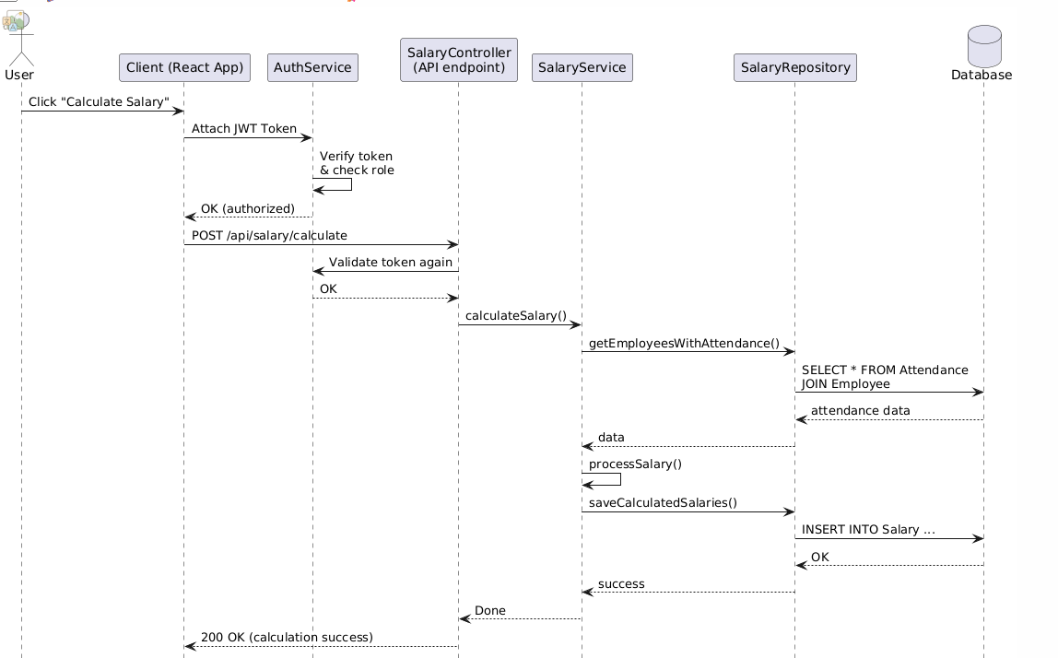
Part 3: Design pattern identification and analysis (2 points)
Given the following pseudocode:
class MoviePlayer
{
// objects of other library classes
VideoEncoder m_videoEncoder;
AudioEncoder m_audioEncoder;
SubtitleSync m_subtitSync;
PlayControler m_ctrl;

// Movie playing method for simle call
public void PlayMovie(string moviePath, string subtitle)
{
auto video = m_videoEncoder.DecodeVideo(moviePath);
auto audio = m_audioEncoder.DecodeAudio(moviePath);
if (subtitle != NULL) {
auto subtit = m_subtitSync.Sync(subtitle);
}
m_ctrl.LoadButton();
m_ctrl.Play(video, audio, subtit);
}
}

// Outside code calls simply:
MoviePlayer moviePlayer = new MoviePlayer();
moviePlayer.PlayMovie("moveFile.mp4", "Hello students!", );

⇒ Đang cung cấp 1 giao đơn giản hơn cho 1 hệ ttthông rat phuc tap

1. What design pattern is used in the code above? Identify its name and pattern family (creational, structural, or behavioral). (0.5 points)
⇒ Facade Pattern THUOC NHOM Structural Pattern
2. Draw Class diagram for this pattern. (1 point)
MoviePlayer
Cac lop con : VideoEncoder , AudioEncoder , SubtitleSync , Playcontroller
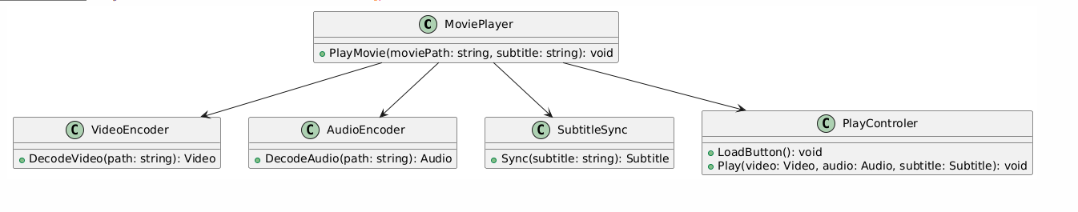
3. Describe a practical situation in software development where this pattern would be appropriate. (0.5 points)
In a media player application (e.g., VLC, Netflix, or a custom movie app), when a user wants to play a movie with subtitles, the system needs to perform several complex tasks:
- Decode the video stream
- Decode the audio stream
- Synchronize subtitles
- Load and control the playback interface
Without a Facade, developers would have to manually call each subsystem in the correct order, increasing complexity and tight coupling.
Using the Facade Pattern, the application provides a single simplified method, such as PlayMovie(), which internally handles all the above steps, making it easy for the user or other modules to trigger movie playback without dealing with internal logic.

Design Pattern | Dấu hiệu nhận biết trong đề (Keyword) | Khi nào dùng
Strategy | “define a family of algorithms”, “interchangeable”, “choose behavior at runtime” | Có nhiều thuật toán hoặc hành vi tương tự nhau và muốn hoán đổi linh hoạt.
Observer | “when one changes, others are notified”, “event-driven” | Khi một đối tượng thay đổi và cần thông báo cho các đối tượng liên quan.
Factory Method | “create objects without specifying the exact class” | Khi cần ẩn đi quá trình tạo đối tượng, và để con lớp con tự quyết định loại object.
Singleton | “only one instance”, “shared resource”, “global access” | Khi cần một đối tượng duy nhất, ví dụ: ConfigManager, Logger, DataConnection
Decorator | “add responsibilities dynamically”, “wrap existing objects” | Khi muốn mở rộng chức năng mà không thay đổi code gốc.
Adapter | “make incompatible interfaces work together” | Khi muốn tương thích 2 giao diện không khớp.
Facade | “provide simplified interface to a complex system” | Khi có hệ thống phức tạp nhưng cần 1 API đơn giản cho người dùng cuối.

